Mini project
Data Analytics
Mini project Title : Housing Prices Data Analytics
Project dataset source link : https://www.kaggle.com/datasets/yasserh/housing-prices-dataset
Folder link : https://drive.google.com/drive/u/0/folders/1egKj1FbhqJK5lrjSybA8s_IhL9qSSEfd
Problem solving : This project, to predict the housing price based on certain factors like house area, bedrooms, furnished, nearness to mainroad, etc. The dataset is small yet, it's complexity arises due to the fact that it has strong multicollinearity.
Tools Used:
• Microsoft Excel: Data Cleaning, Transformation, and Validation
• Power BI: Data Modeling, Data visualization and Report
Data Cleaning and Transformation in Excel
HOUSHING PRICES Data
- Checking Missing Values in all field - There is no missing values
- Checking Duplicates - No Duplicates
- Trim() used in all fields
- Proper() used for Headings and Text Using Fields
- Standardized and corrected inconsistent entries
- Imputed total rooms in housing prices average
- Change the Data Type like Numbered Column Price - change to currency

Data Visualization using Power BI
- Donut chart - Furnishing status vs price category
- Scatter chart - Price category used to average area and price
- Pie chart - Parking vs BHK rooms
- Line chart - Furnishing status vs Price
- Clustered bar chart - Furnishing status by price category and guestroom
- Map - Area vs Furnishing status
- Table - Guest room vs BHK bedrooms and price
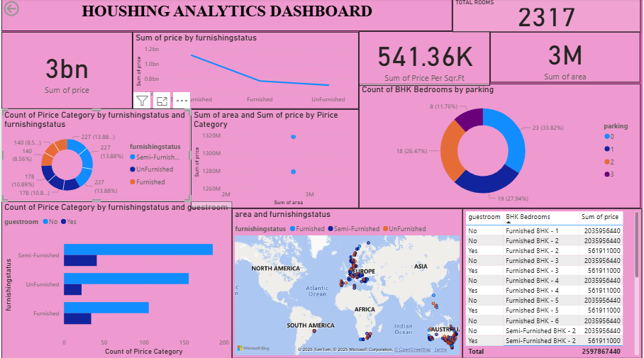

Types of analysis
- Descriptive analysis : A histogram of the sale price often reveals a right-skewed distribution, indicating that most properties are clustered at the lower end of the price spectrum, with a long tail of a few high-priced, luxury properties
- Diagnostic analysis : Assess the percentage of missing values for each feature. Features with many missing values may need to be dropped or impute
- Predictive analysis : Estimating how long a specific property is likely to stay on the market before it sells
- Prescriptive analysis : The most profitable type of housing to build and the optimal location to build it to meet that demand.

Conclusion
- The final summary would identify the most effective model and the key factors influencing house prices

